3

Варианты

Nr | Имя |  |  |  | 1 | 2 | 3 | 4 | 5 | 6
1 | Artjom |  | Amintšikov |  | a, b | c, d | a | 1, 2 | 1 | a
2 | Ljubov |  | Anissimova |  | c, d | a, b | b | 3, 4 | 2 | b
3 | Aleksandr |  | Babilo |  | e, i | e, i | c | 5, 6 | 3 | c
4 | Viktoriya |  | Koltsova |  | j, k | b, d | d | 7, 8 | 4 | d
5 | Gennadi |  | Izmestjev |  | a, c | c, i | a | 1, 8 | 1 | a
6 | Sergei |  | Kazakov |  | a, e | a, i | c | 2, 7 | 2 | b
7 | Maxim |  | Koltsov |  | i, j | b. e | b | 3, 6 | 3 | c
8 | Eduard |  | Kriina |  | k, a | d, e | a | 4, 5 | 4 | d
9 | Ivan |  | Kuzmin |  | j, b | c, e | d | 1, 4 | 1 | a
10 | Enno |  | Kõuts |  | i, c | c, b | b | 2, 3 | 2 | b
11 | Andrei |  | Mihhaltšuk |  | c, b | e, i | c | 5, 8 | 3 | c
12 | Merilin |  | Mutli | õkv | d, a | d, i | d | 6, 7 | 4 | d
 |  |  | Tartu
 |  |  | kolledžist
13 | Mikalai |  | Nazarchuk |  | e, k | e, a | a | 3, 7 | 1 | a
14 | Tatjana |  | Bragina |  | i, a | a, d | b | 6, 8 | 2 | b
15 | Anastassia |  | Prokofjeva |  | j, k | c, i | a | 5, 7 | 1 | a
16 | Anton |  | Roor |  | c, e | b, i | b | 2, 4 | 3 | c
17 | Tatjana |  | Skljarova |  | d, a | a, c | d | 8, 3 | 1 | a
18 | Anna |  | Smirnova |  | j, k | e, i | c | 3, 6 | 1 | c
19 | Gleb |  | Sokolov |  | a, b | c, i | a | 4,7 | 3 | b
20 | Anna |  | Soltruk * |  | k, c | d, b | d | 4, 5 | 4 | d
21 | Aleksei |  | Voljanjuk |  | j, a | c, e | d | 1, 3 | 1 | c
22 | Maxim |  | Voskresenskiy |  | k, d | i, b | b | 8, 5 | 3 | d
23 | Nikita |  | Pisnja |  | d, a | d, i | d | 6, 7 | 4 | d
24 | Aleksander |  | Bazutin |  | k, c | d, b | d | 4, 5 | 4 | d
25 | Viktorija |  | Bagrova |  | d, b | d, j | c | 6, 8 | 4 | d
26 | Darja |  | Khaustova |  | b, c | i, b | d | 7, 5 | 4 | a
27 | Vladislav |  | Possaškov |  | j, b | e, d | c | 2, 6 | 3 | c
28 | Tatjana |  | Romanenko |  | i, k | c, e | b | 7, 3 | 2 | b
29 | Valeri |  | Gorbatšjov |  | j, c | c, k | d | 2, 8 | 3 | a

4

Задание 1.

Проверить статическую неопределимость и геометрическую неизменяемость системы

a) | F= 40 kN | p = 15 kN/m
 | 2,25 m | 1,5 m
 | 4,5 m | 6,0 m
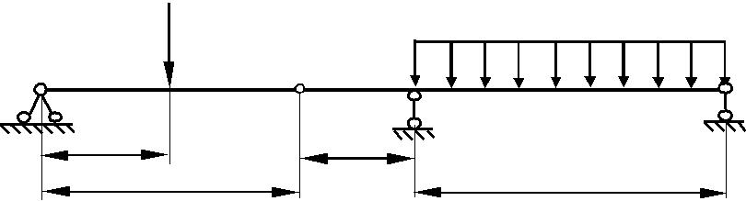

b)

A

3,0 m

F= 20 kN
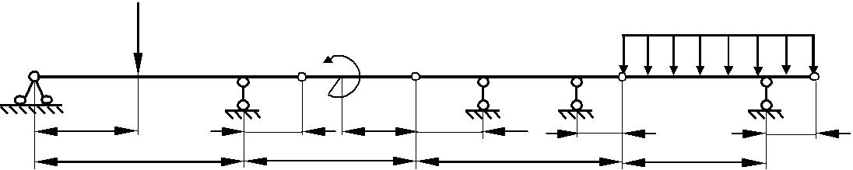
 |  | M= 30 kN m
B | C | D | E

1,5 m | 2,0 m | 1,5 m

6,0 m | 4,5 m | 5,5 m

 |  | p = 20 kN/m
F | G | H
1,0 m |  | 1,0 m
 |  | 4,0 m

c)
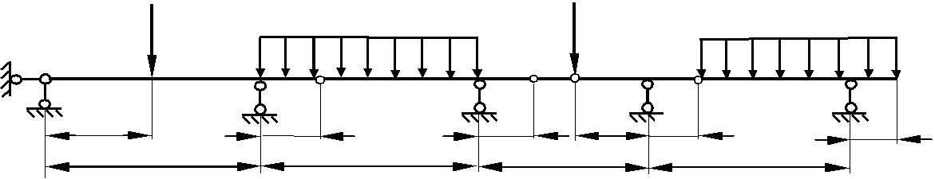
F₁= 20 kN |  |  | p = 12 kN/m |  |  |  | F₂= 25 kN |  |  | p = 12 kN/m
A
B |  |  | C |  | D E |  | F G |  |  | H
 | 3,0 m | 1,5 m |  | 1,5 m |  | 2,0 m |  | 1,0 m | 1,0 m
 |  | 6,0 m |  | 6,0 m |  | 5,5 m |  |  | 5,0 m

d)

p = 12 kN/m
1,0 m | 1,0 m
4,0 m | 2,0 m

e)

 |  |  |  |  |  | F₂= 10 kN | p = 12 kN/m
F₁= 20 kN |  |  |  |  |  | F₂= 10 kN | p = 12 kN/m
F₁= 20 kN |  | F = 20 kN |  | F₁= 20 kN |  | F₂= 10 kN | p = 12 kN/m
 |  | 1 |  | F₁= 20 kN
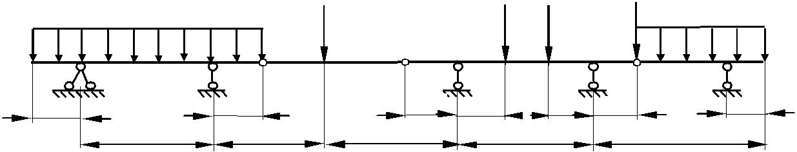

1,0 m | 1,5 m | 1,5 m | 1,0 m | 1,0 m
4,0 m |  | 4,0 m |  | 6,0 m
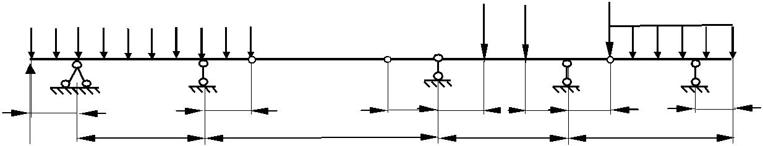

p = 12 kN/m |  |  |  |  |  | F₂= 10 kN | p = 12 kN/m
p = 12 kN/m |  | F₁= 20 kN
p = 12 kN/m |  | F₁= 20 kN |  | F₁= 20 kN |  | F₂= 10 kN | p = 12 kN/m

F₁ = 20 kN | 1,0 m | 1,0 m | 1,5 m | 1,5 m | 1,0 m | 1,0 m
1,0 m
4,0 m | 6,0 m |  |  | 4,0 m |  | 6,0 m

^{i)} F = 160 kN | M = 60 kN. m |  | p = 40 kN/m
A | B
 |  | C | D | E
1 m | 0,5 m 0,5 m | 1 m | 1 m | 1 m
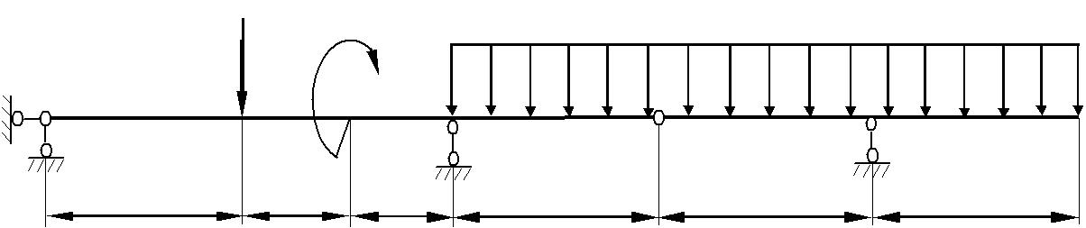

5

j) | p₁ = 10 kN/m |  |  | F = 40 kN |  |  | p₂ = 20 kN/m
A |  |  | D |  |  |  |  |  | K
B | C |  |  | E |  | F | G | H | K
1 m | 3 m | 1,5 | 3 m | 3 m | 1,5 | 4 m | 1,5 |  | 4,5
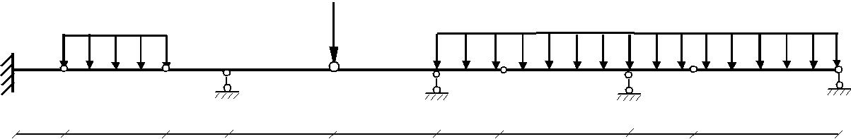

k)
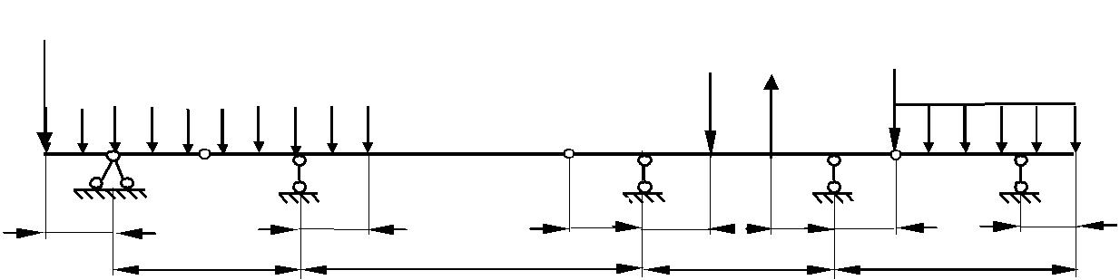
F₁= 20 kN
p = 12 kN/m |  |  |  |  |  | F₂= 10 kN | p = 12 kN/m
p = 12 kN/m |  | F₁= 20 kN |  | F₁= 20 kN |  | F₂= 10 kN | p = 12 kN/m

1,0 m | 1,0 m | 1,0 m | 1,5 m | 1,5 m | 1,0 m | 1,0 m
4,0 m | 6,0 m |  |  | 4,0 m |  | 6,0 m

Рисонок 1

6

Задание 2.

Определите для показанной на рисунке 2.рамной cистемы статическую неопределимость и исследовать геометрическую изменяемость.

a) | p₁ = 50 kN/m |  |  |  |  |  |  |  | p₂ = 40 kN/m
 | H |  | ^{E} 1,0 m |  |  |  |  |  | D | 1,0 m^{G} | J
 |  | 1,0 m | ^{E} 1,0 m | C |  | 5,5 m |  |  | D | 1,0 m^{G} | 1,0 m
m
2.0 | 1,0 m | A | F = 120 kN |  |  |  |  |  |  |  | 4,0 m
 |  |  |  |  |  |  |  |  |  |  | B
 | b) |  |  | F₁ = 20 kN |  |  | M = 10 kNm
 |  |  | E |  |  | C |  |  | D
 |  |  | 1,0 m |  | 1,5 m | 2,0 m |  | m
 |  |  |  |  |  |  |  | 1,0 | F₂ = 30 kN
 | 3,0 m | = 5 kN m/ |  |  |  |  |  | 2,0 m
 |  | p |  |  |  |  |  |  | B
 |  |  | A |  |  |  |  |  | B
 |  |  |  |  | 5,0 m
c) |  |  |  | p = 8 kN/m |  |  | F = 40 kN
c) |  |  |  |  |  |  |  |  | M = 15 kNm
 |  |  |  |  |  | G |  | J
 |  |  | D |  | E | G |  | J |  | C
 |  |  |  | 2,5 m | 1,5 m | 1,0 m | 1,0 m | 1,0 m | 1,5 m
 |  | 3,0 m
 |  |  | A |  |  | B
 |  | d) |  | p = 8 kN/m |  |  |  |  | F₁ = 15 kN
 |  |  |  |  |  | G |  | J
 |  |  | D |  | E | G |  | J |  | C
 |  |  |  | 2,5 m | 1,5 m | 1,0 m | 1,0 m | 1,0 m |  | 1,5 m
 |  | 3m |  |  |  | F₂ = 40
 |  | 3,0
 |  |  | A |  |  | B
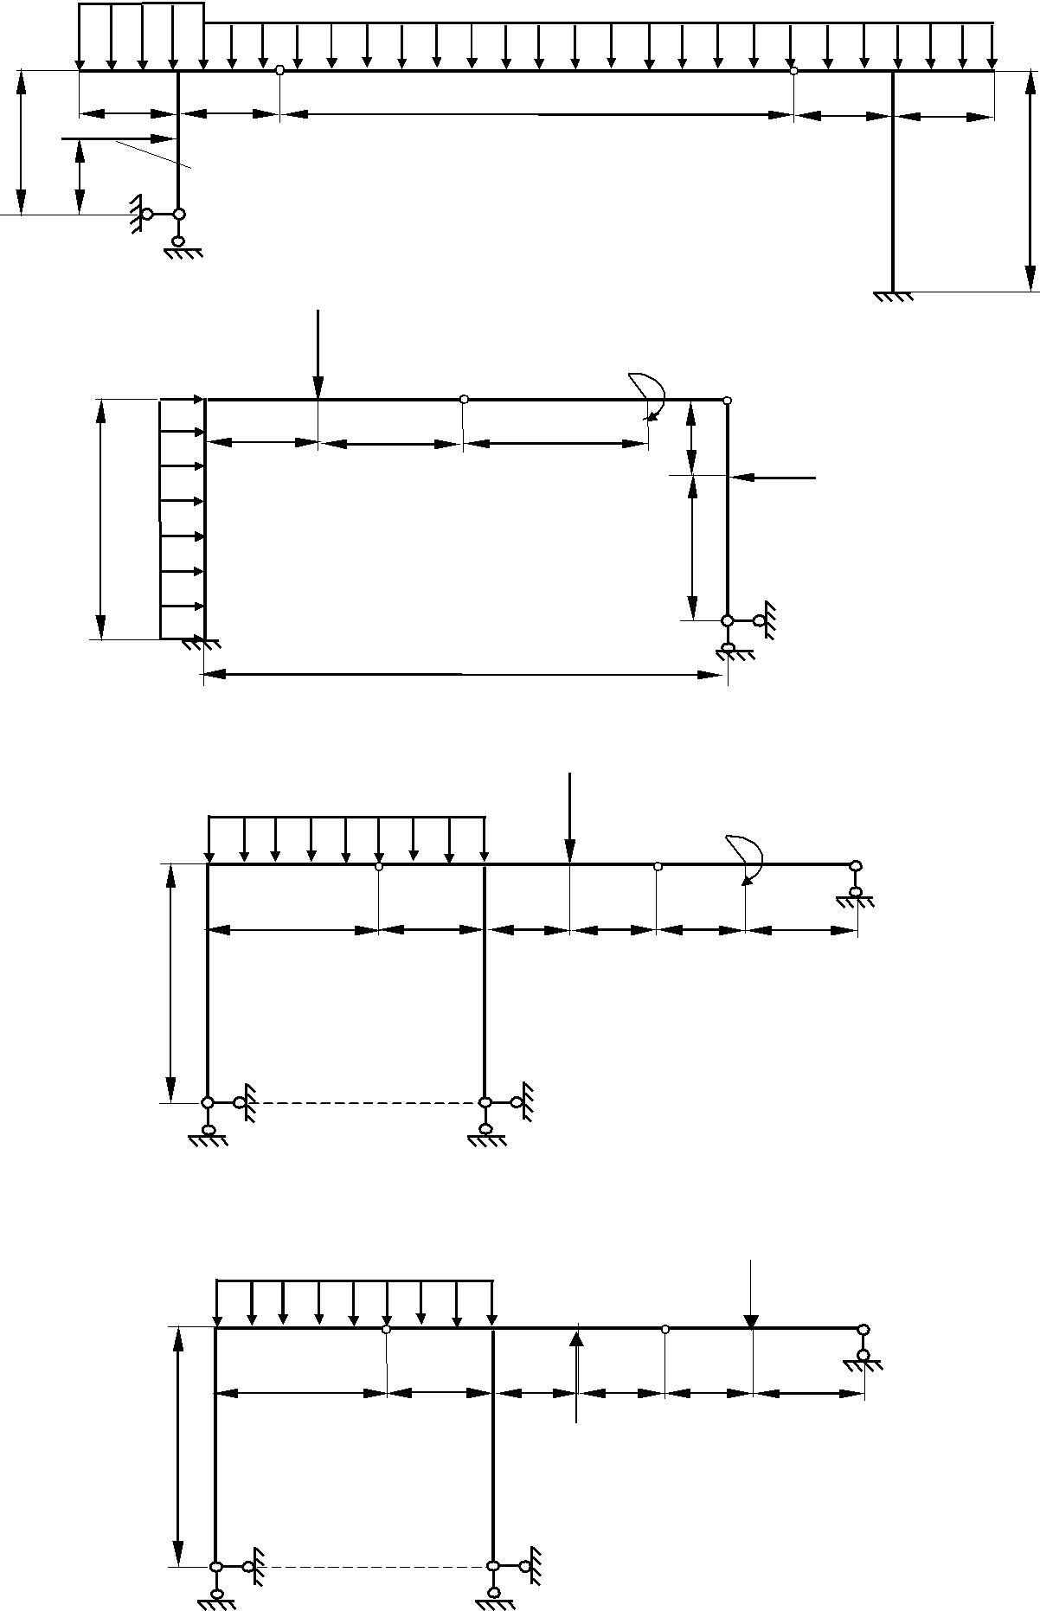

7

e)
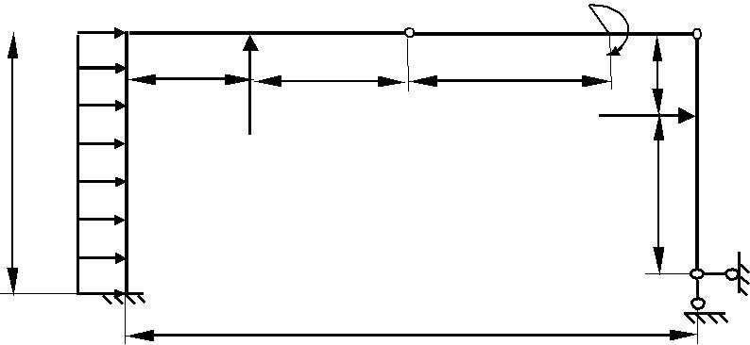
E C

 |  | 1,0 m |  | 1,5 m
3,0 m | kN m/
3,0 m |  |  | F₁ = 20 kN
 | p = 5

A

5,0 m

 | i)
 |  |  |  |  |  |  | F₁ = 20 kN
 |  |  |  | E
 |  |  |  |  | 1,0 m |  |  | 3,5 m
 |  | kN| m
3m |  | P=5
 |  |  |  | A
 |  |  |  |  |  |  |  | 5,0 m
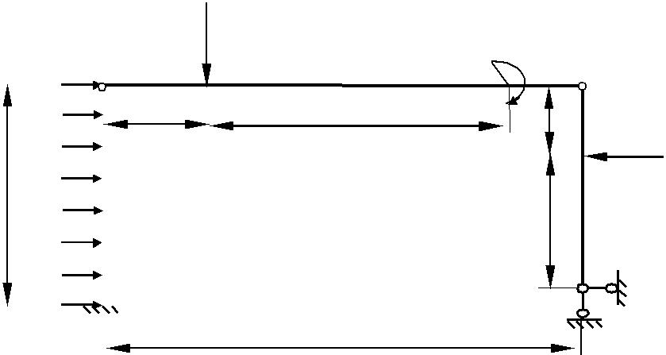

 |  | M = 20 kNm
 |  |  |  |  | D
2,0 m |  |  | m
 |  | 1,0
 | F₂ = 40 kN
 |  |  |  | 2,0 m

B

M = 10 kNm

 |  | D
1,0 m |  | F₂ = 30 kN
 | 2,0 m

B

рисунок 2.

8

Задание 3.
Раскрыть статическую неопределимую фермы ,найти внутренние силы стержней в опоре A,методом вырезания углов.

a) |  | F
 | F |  | F
F/2 |  |  | F | h=5,0
A |  |  |  | B
d=2,0 |  | F
b) |  | F
 | F |  | F
F/2 |  |  | F/2 | h
A |  |  |  | B
d
c)
F/2 | F | F | F | F/2
 |  |  |  | h=4,0
A |  |  |  | B
d=2,0
d)
F/2 | F | F | F | F/2
 |  |  |  | h
A |  |  |  | B
d
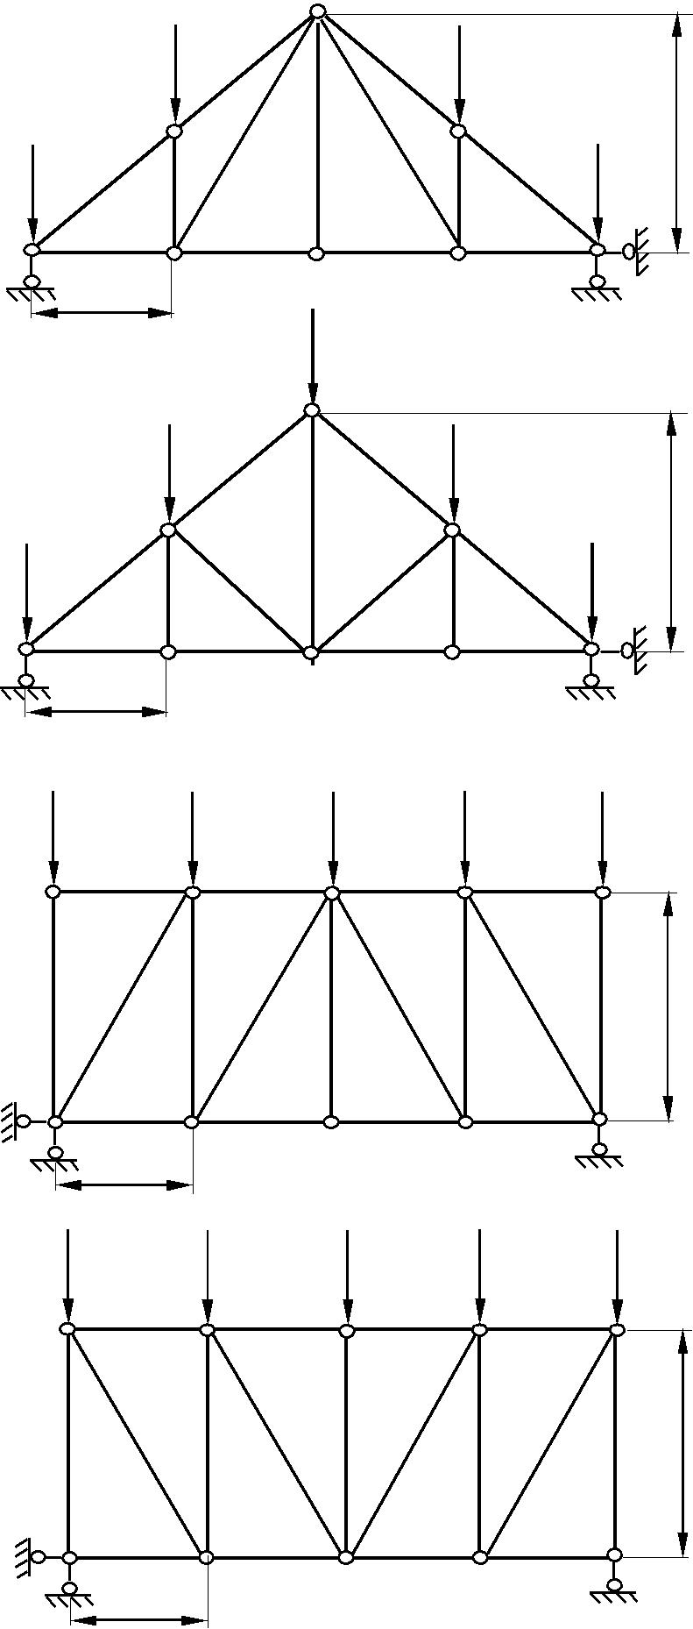
9
Рисунок 3

задание4.

Раскрыть неопределимость, проверить на неизменяемость.
Составить все возможные варианты основных схем. Найти оптимальный вариант из них.
Для выбранного варианта составить коническое уравнение метода сил.

1 |  | p= 40 kN/m
 | A
 |  | B
 | 1 m | 2 m | 1 m
 |  |  | F = 160 kN
 | p= 40 kN/m |  | F = 160 kN
2. | A | C
 |  | B
 | 6 m | 1 m | 1 m
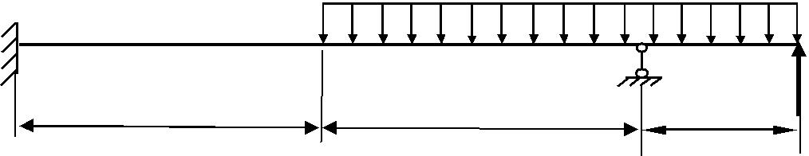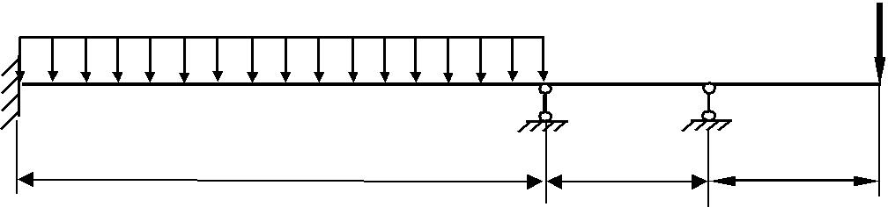

F = 160 kN

 |  | p= 40 kN/m
 | A
3. | C | B | D
 | 4 m | 2 m | 2 m
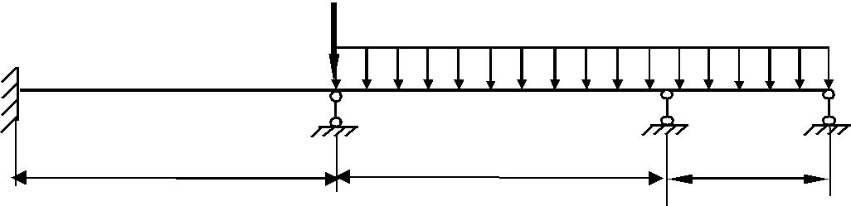

4. |  |  | p= 40 kN/m |  |  |  | F = 160 kN
 | A |  |  |  |  |  |  | C
 |  |  |  |  | B
5. |  |  | 6 m | 1 m |  |  |  | 1 m
5. |  |  | p= 40 kN/m
5. |  |  | p= 40 kN/m |  |  |  |  | M = 60 kN. m
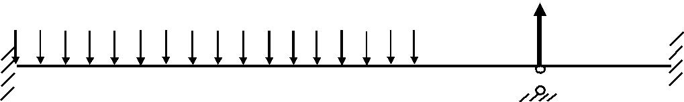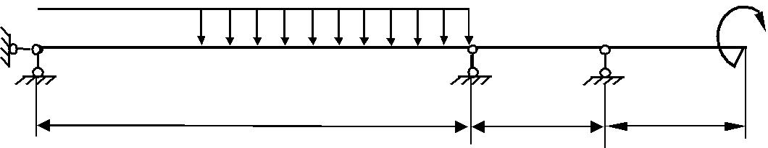
A
C |  | B
6 m | 2 m | 2 m

10

M = 60 kN. m
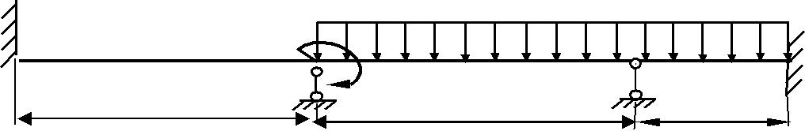A
6.

p= 40 kN/m

4 m | C | B | D
 | 4 m |  | 2 m

F = 160 kN
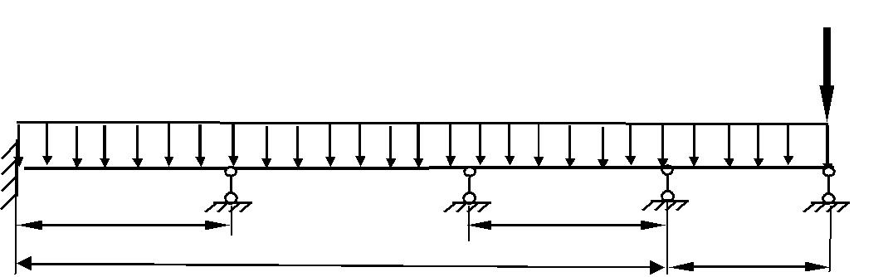
A |  | p= 40 kN/m
7. |  |  | B | E
2 m | C | D | B | E
2 m |  |  | 2 m
 |  | 6 m |  | 2 m
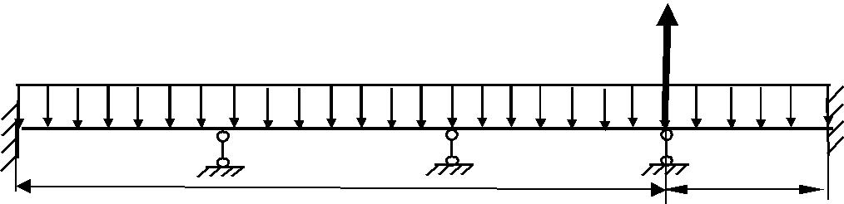

p= 40 kN/m | F = 160 kN

8. | A |  | B
 | C | D | B | E
 | 6 m | D | 2 m | E

рисунок 4

11

задание5.
Раскрыть неопределимость, проверить на неизменяемость.
Составить все возможные варианты основных схем. Найти оптимальный вариант из них.
Для выбранного варианта составить коническое уравнение метода сил.

1 p=10kH/m
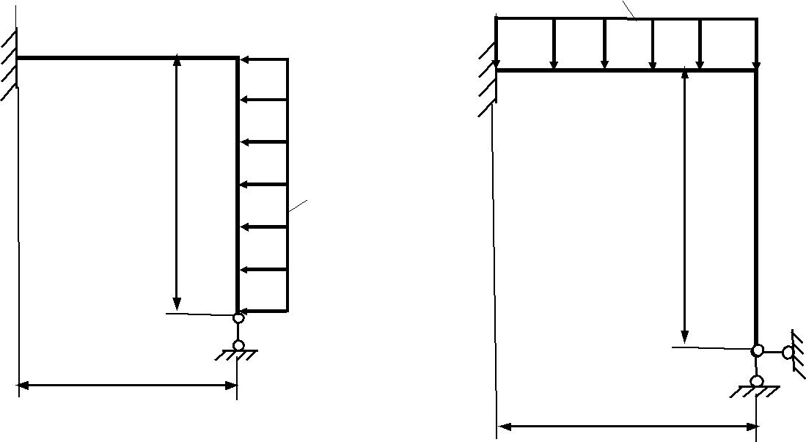

2m

2m | p=10kH/m
2m | 2m

1m

1m

2 p=5kH/m
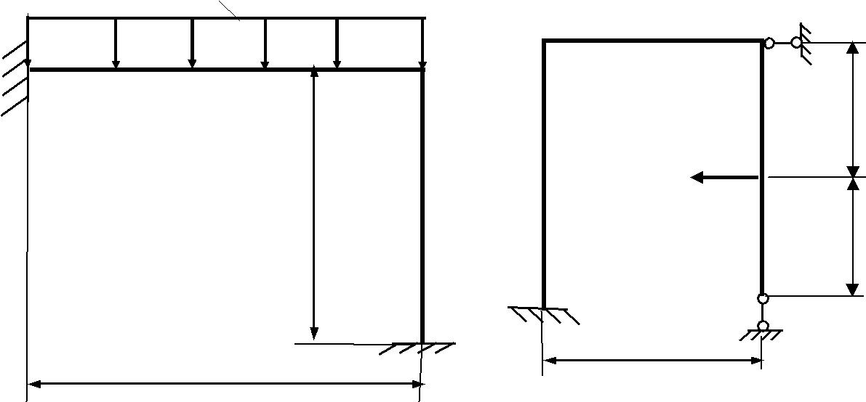

F=5kH

1m

1m
1m
5661m | 1m
2m | 1m

12

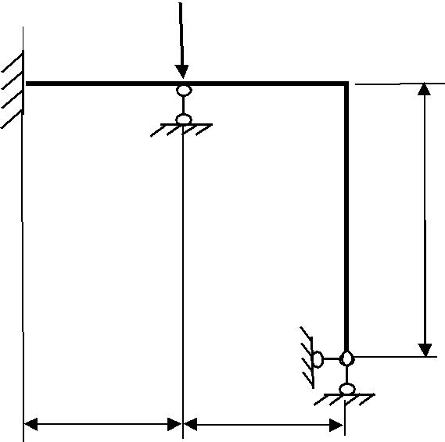

F=5kH

3

2m

^{1m} 1m

M = 60 kN. m
4.
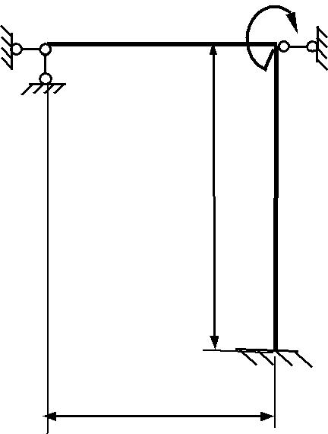

2m

1m

F=5kH
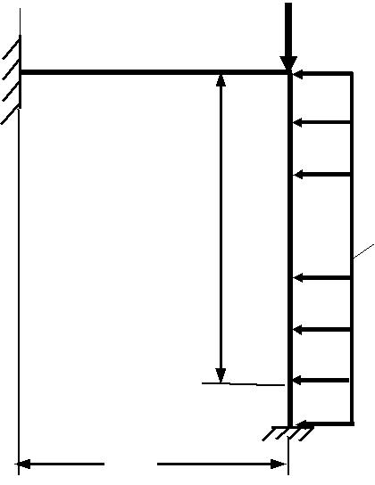

p=10kH/m
2m

1m

_{0,5m} M = 60 kN. m
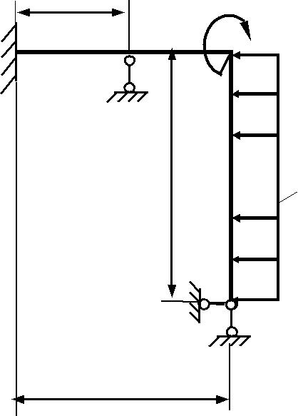

p=10kH/m
2m

1m

рисунок 5

13

задание6.
Расчитать изображенной на рисунке 6 балку и сечение узла рамы С.

a)

p= 40 kN/m |  | M = 60 kN. m
A | B | C
6 m | 2 m | 2 m
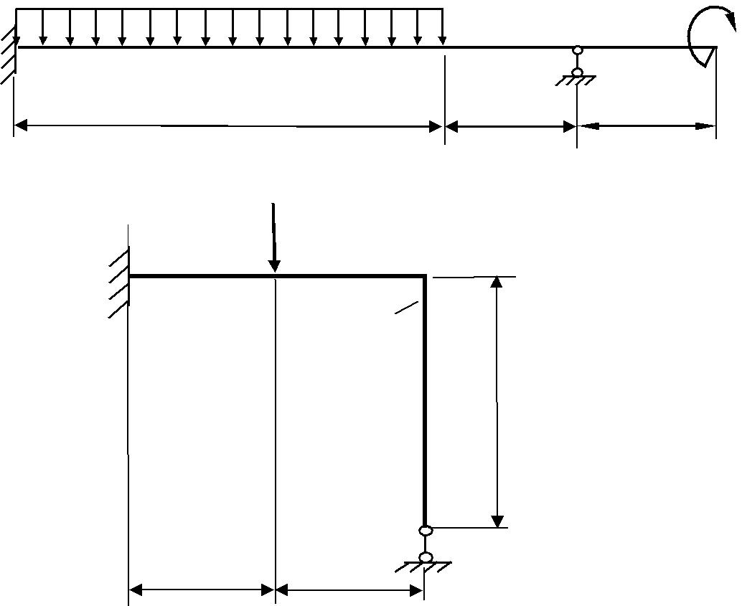

F=5kH

C

EI

2EI

2m

1m _{1m}

b)
_{M} _{= 60 kN}. _{m} ^{p= 40 kN/m}
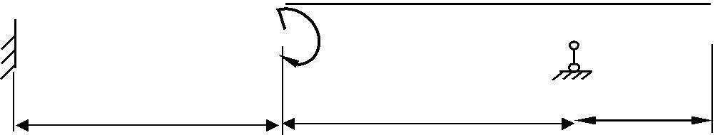
C _{C}

B

4 m | 4 m | 2 m

1/2m
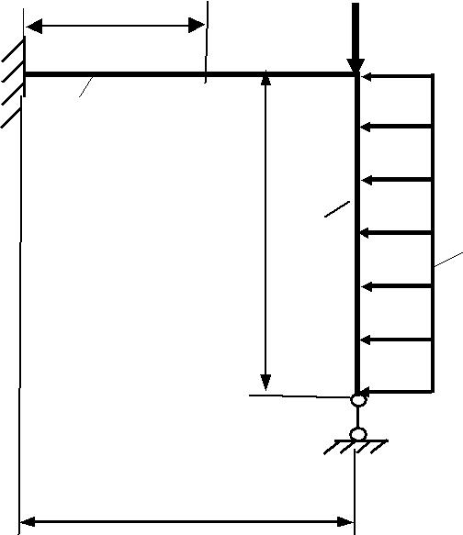F=5kH

C

EI

2m

C

2EI

p=10kH/m

1m

14

c) | p= 40 kN/m |  | F = 160 kN
 | A |  | C
 |  | B | C
 | 6 m |  | 2 m
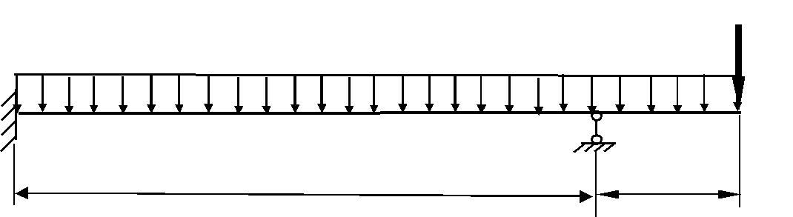

M = 60 kN. m
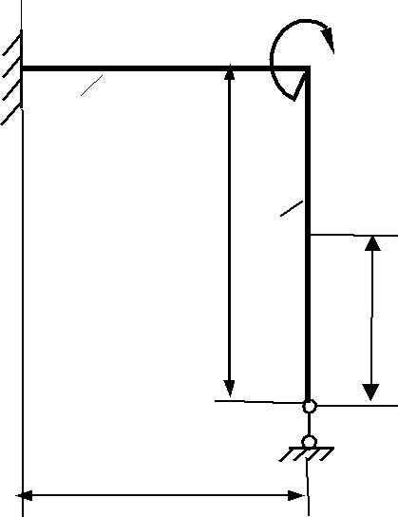

EI

2m

1m

d)

p= 40 kN/m

C

2EI

1m
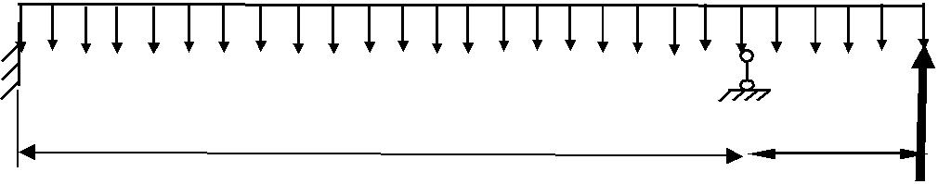

A
C
B

6 m | 2 m

F = 160 kN

^{1/2m} M = 60 kN. m
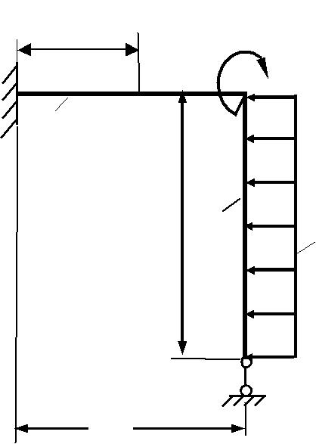

C

EI

2m

p=10kH/m
2EI

1m

рисунок 6 | 15

