Structural Steel Shapes
Steel sections used for construction are available in a variety of shapes and sizes. In general, there are three procedures by which steel shapes can be formed: hot rolled, cold formed, and welded. All steel shapes must be manufactured to meet ASTM standards. Commonly used steel shapes include the wide flange (W) sections, the American Standard beam (S) sections, bearing pile (HP) sections, American Standard channel (C) sections, angle (L) sections, and tee (WT) sections, as well as bars, plates, pipes, and hollow structural sections (HSS). I sections that, by dimensions, can not be classified as W or S shapes are designated miscellaneous (M) sections, and C sections that, by dimensions, can not be classified as American Standard channels are designated miscellaneous channel (MC) sections.
Hot-rolled shapes are classified in accordance with their tensile property into five size groups by the American Society of Steel Construction (AISC). The groupings are given in the AISC manuals [AISC, 1989, 2001]. Groups 4 and 5 shapes and group 3 shapes with a flange thickness exceeding 1/ in. are generally used for application as compression members. When weldings are used, care must be exercised to minimize the possibility of cracking in regions at the vicinity of the welds by carefully reviewing the material specification and fabrication procedures of the pieces to be joined.
Structural Fasteners
Steel sections can be fastened together by rivets, bolts, and welds. Although rivets were used quite extensively in the past, their use in modern steel construction has become almost obsolete. Bolts have essentially replaced rivets as the primary means to connect nonwelded structural components.

Bolts
Four basic types of bolts are commonly in use. They are designated by ASTM as A307, A325, A490, and A449 [ASTM, 2001a, 2001b, 2001c, 2001d]. A307 bolts are called common, unfinished, machine, or rough bolts. They are made from low-carbon steel. Two grades (A and B) are available. They are available in diameters from 1/4 to 4 in. (6.4 to 102 mm) in 1/8-in. (3.2-mm) increments. They are used primarily for low-stress connections and for secondary members. A325 and A490 bolts are called high-strength bolts. A325 bolts are made from a heat-treated medium-carbon steel. They are available in two types: type 1, bolts made of medium-carbon steel; and type 3, bolts having atmospheric corrosion resistance and weathering characteristics comparable to those of A242 and A588 steel. A490 bolts are made from quenched and tempered alloy steel and thus have a higher strength than A325 bolts. Like A325 bolts, two types (types 1 and 3) are available. Both A325 and A490 bolts are available in diameters from 1/2 to 1/ in. (13 to 38 mm) in 1/8-in. (3.2-mm) increments. They are used for general construction purposes. A449 bolts are made from quenched and tempered steel. They are available in diameters from 1/4 to 3 in. (6.4 to 76 mm). Because A449 bolts are not produced to the same quality requirements or same heavy hex head and nut dimensions as A325 or A490 bolts, they are not to be used for slip critical connections. A449 bolts are used primarily when diameters over 1/ in. (38 mm) are needed. They are also used for anchor bolts and threaded rods.
High-strength bolts can be tightened to two conditions of tightness: snug tight and fully tight. Snug- tight conditions can be attained by a few impacts of an impact wrench or the full effort of a worker using an ordinary spud wrench. Snug-tight conditions must be clearly identified on the design drawing and are permitted in bearing-type connections where a slip is permitted or in tension or combined shear and tension applications where loosening or fatigue due to vibration or load fluctuations is not a design consideration. Bolts used in slip-critical conditions (i.e., conditions for which the integrity of the connected parts is dependent on the frictional force developed between the interfaces of the joint) and in conditions where the bolts are subjected to direct tension are required to be tightened to develop a pretension force equal to about 70% of the minimum tensile stress F_{u} of the material from which the bolts are made. This can be accomplished by using the turn-of-the-nut method, the calibrated wrench method, alternate design fasteners, or direct tension indicators [RCSC, 2000].
TABLE 48.2 Electrode Designations
Welding | Electrode
Processes | Designations | Remarks
Shielded metal | E60XX | The E denotes electrode; the first two digits indicate tensile strength in ksiª; the two
arc welding | E70XX | X’s represent numbers indicating the electrode use
(SMAW) | E80XX  E100XX  E110XX
Submerged arc | F6X-EXXX | The F designates a granular flux material; the digit(s) following the F indicate the
welding | F7X-EXXX | tensile strength in ksi (6 means 60 ksi, 10 means 100 ksi, etc.); the digit before the
(SAW) | F8X-EXXX | hyphen gives the Charpy V-notched impact strength; the E and the X’s that follow
 | F10X-EXXX | represent numbers relating to the electrode use
 | F11X-EXXX
Gas metal arc | ER70S-X | The digits following the letters ER represent the tensile strength of the electrode in ksi
welding | ER80S
(GMAW) | ER100S  ER110S
Flux cored arc | E6XT-X | The digit(s) following the letter E represent the tensile strength of the electrode in
welding | E7XT-X | ksi (6 means 60 ksi, 10 means 100 ksi, etc.)
(FCAW) | E8XT  E10XT  E11XT
ª 1 ksi = 6.895 MPa.

Weldability of Steel
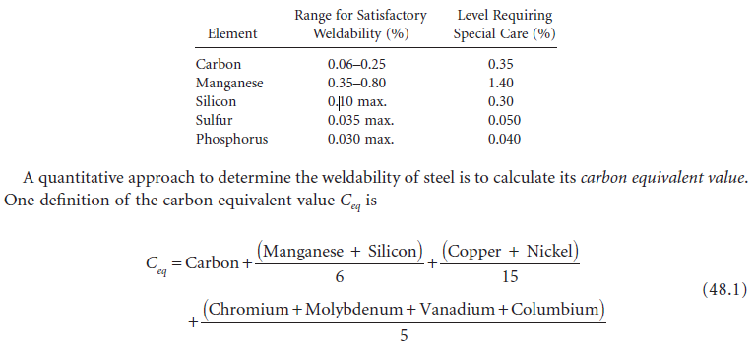
Weldability is the capacity of a material to be welded under a specific set of fabrication and design conditions and to perform as expected during its service life. Generally speaking, weldability is considered very good for low-carbon steel (carbon level, <0.15% by weight), good for mild steel (carbon level, 0.15 to 0.30%), fair for medium-carbon steel (carbon level, 0.30 to 0.50%), and questionable for high-carbon steel (carbon level, 0.50 to 1.00%). Because weldability normally decreases with increasing carbon content, special precautions such as preheating, controlling heat input, and postweld heat treating are normally required for steel with a carbon content reaching 0.30%. In addition to carbon content, the presence of other alloying elements will have an effect on weldability. In lieu of more accurate data, the table below can be used as a guide to determine the weldability of steel [Blodgett, undated].

A steel is considered weldable if C_{eq} < 0.50% for steel in which the carbon content does not exceed 0.12%, and if C_{eq} < 0.45% for steel in which the carbon content exceeds 0.12%.
The above equation indicates that the presence of alloying elements decreases the weldability of steel. An example of high-alloy steels is stainless steel. There are three types of stainless steel: austenitic, martensitic, and ferritic. Austenitic stainless steel is the most weldable, but care must be exercised to prevent thermal distortion, because heat dissipation is only about one third as fast as it is in plain carbon steel. Martensitic steel is also weldable, but prone to cracking because of its high ability to harden. Preheating and the maintaining of an interpass temperature are often needed, especially when the carbon content is above 0.10%. Ferritic steel is weldable, but decreased ductility and toughness in the weld area can present a problem. Preheating and postweld annealing may be required to minimize these undesirable effects.

  - Design Philosophy and Design Formats

Design Philosophy
Structural design should be performed to satisfy the criteria for strength, serviceability, and economy. Strength pertains to the general integrity and safety of the structure under extreme load conditions. The structure is expected to withstand occasional overloads without severe distress and damage during its lifetime. Serviceability refers to the proper functioning of the structure as related to its appearance, maintainability, and durability under normal, or service load, conditions. Deflection, vibration, permanent deformation, cracking, and corrosion are some design considerations associated with serviceability. Economy is concerned with the overall material, construction, and labor costs required for the design, fabrication, erection, and maintenance processes of the structure.

Design Formats
At present, steel design in the U.S. can be performed in accordance with one of the following three formats:
Allowable stress design (ASD), which has been in use for decades for the steel design of buildings and bridges. It continues to enjoy popularity among structural engineers engaged in steel building design. In allowable stress (or working stress) design, member stresses computed under service (or working) loads are compared to some predesignated stresses called allowable stresses. The allowable stresses are often expressed as a function of the yield stress (F_{y}) or tensile stress (F_{u}) of the material divided by a factor of safety. The factor of safety is introduced to account for the effects of overload, understrength, and approximations used in structural analysis. The general format for an allowable stress design has the form

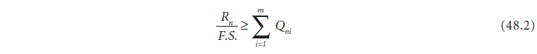
where R_{n} = the nominal resistance of the structural component expressed in unit of stress (i.e., the allowable stress)
Q_{ni} = the service, or working, stresses computed from the applied working load of type FS. = the factor of safety, i is the load type (dead, live, wind, etc.)
m = the number of load type considered in the design

Plastic design (PD), which makes use of the fact that steel sections have reserved strength beyond the first yield condition. When a section is under flexure, yielding of the cross section occurs in a progressive manner, commencing with the fibers farthest away from the neutral axis and ending with the fibers nearest the neutral axis. This phenomenon of progressive yielding, referred to as plastification, means that the cross section does not fail at first yield. The additional moment that a cross section can carry in excess of the moment that corresponds to first yield varies, depending on the shape of the cross section. To quantify such reserved capacity, a quantity called the shape factor, defined as the ratio of the plastic moment (moment that causes the entire cross section to yield, resulting in the formation of a plastic hinge) to the yield moment (moment that causes yielding of the extreme fibers only) is used. The shape factor for hot-rolled I-shaped sections bent about the strong axes has a value of about 1.15. The value is about 1.50 when these sections are bent about their weak axes.
For an indeterminate structure, failure of the structure will not occur after the formation of a plastic hinge. After complete yielding of a cross section, force (or, more precisely, moment) redistribution will occur in which the unyielded portion of the structure continues to carry any additional loadings. Failure will occur only when enough cross sections have yielded, rendering the structure unstable, resulting in the formation of a plastic collapse mechanism.
In plastic design, the factor of safety is applied to the applied loads to obtain factored loads. A design is said to have satisfied the strength criterion if the load effects (i.e., forces, shears, and moments) computed using these factored loads do not exceed the nominal plastic strength of the structural component. Plastic design has the form
where R_{n} = the nominal plastic strength of the member
Q_{ni} = the nominal load effect from loads of type i
g = the load factor
i = the load type
m = the number of load types.

In steel building design, the load factor is given by the AISC specification as 1.7 if Q_{n} consists of dead and live gravity loads only, and as 1.3 if Q_{n} consists of dead and live gravity loads acting in conjunction with wind or earthquake loads.
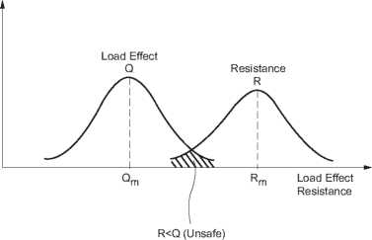
Load and resistance factor design (LRFD) which is a probability-based limit state design procedure. A limit state is defined as a condition in which a structure or structural component becomes unsafe (i.e., a violation of the strength limit state) or unsuitable for its intended function (i.e., a violation of the serviceability limit state). In a limit state design, the structure or structural component is designed in accordance to its limits of usefulness, which may be strength related or serviceability related. In developing the LRFD method, both load effects and resistance were treated as random variables. Their variabilities and uncertainties were represented by frequency distribution curves. A design is considered satisfactory according to the strength criterion if the resistance exceeds the load effects by a comfortable margin. The concept of safety is represented schematically in Fig. 48.2. Theoretically, the structure will not fail unless the load effect Q exceeds the resistance R, as shown by the shaded portion in the figure. The smaller this shaded area, the less likely that the structure will fail. In actual design, a resistance factor f is applied to the nominal resistance of the structural component to account for any uncertainties associated with the determination of its strength, and a load factor g is applied to each load type to account for the uncertainties and
difficulties associated with determining its actual load magnitude. Different load factors are used for different load types to reflect the varying degree of uncertainties associated with the determination of load magnitudes. In general, a lower load factor is used for a load that is more predicable, and a higher load factor is used for a load that is less predicable. Mathematically, the LRFD format takes the form
where fR_{n} represents the design (or usable) strength and S_{i}Q_{ni} represents the required strength or load effect for a given load combination. Table 48.3 shows examples of load combinations [ASCE, 1998] to be used on the right-hand side of Eq. (48.4). For a safe design, all load combinations should be investigated and the design based on the worst-case scenario.

